Jimi Porter

CIS 411

2/28/2021

Week 7 Assignment

/\* 1. Count the number of records in the table \*/

select count(\*) from customers

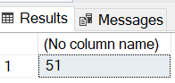

/\* 2. Select everything from the Customers table \*/

select \* from Customers

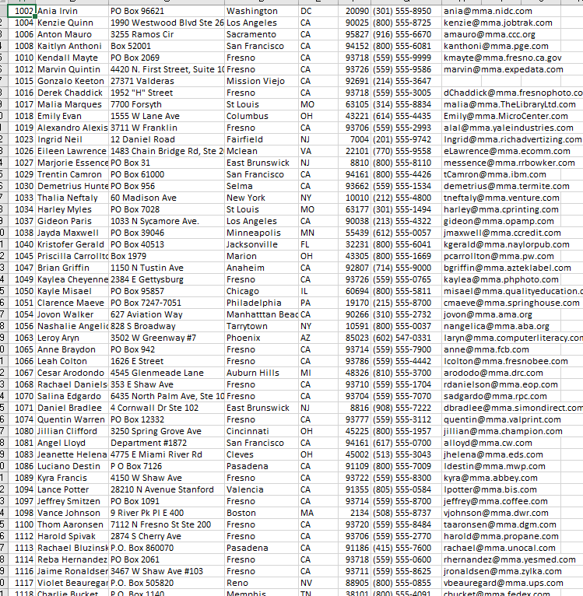

/\* 3. Select everything from the Customers table for California, sort by zipcode \*/

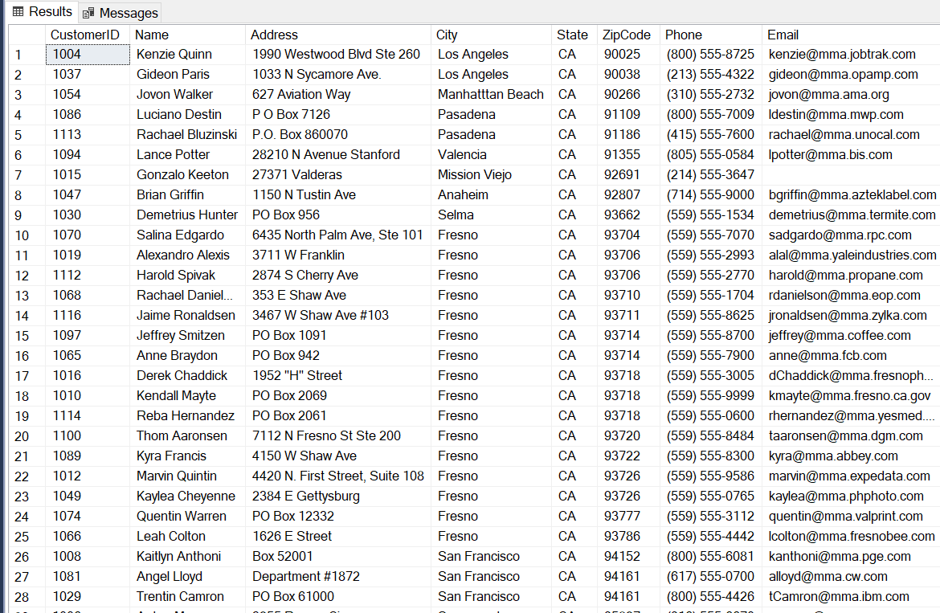select \* from Customers where State ='ca' order by ZipCode

/\* 4. Select everything from the Customers table where the state is California and the zipcode is 93718 \*/

select \* from Customers where State = 'ca' and ZipCode = 93718

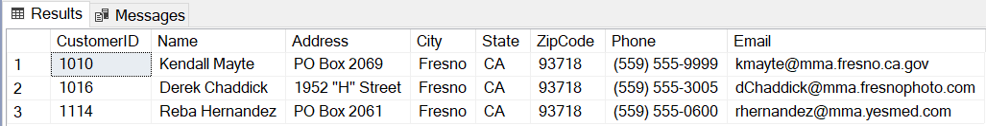

/\* 5. Add literal text and select the Name from the Customers table where the state is California and the zipcode is 93718 \*/

select 'Name: ' + Name from Customers where State = 'ca' and ZipCode = 93718

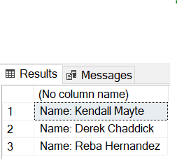

/\* 6. Add literal text and select the Name and add an alias from the Customers table where the state is California and the zipcode is 93718 \*/

select 'Name: ' + Name as CustomerName from Customers where State = 'ca' and ZipCode = 93718

/\* 7. Add literal text and select the Name and add an alias that has a space in it from the Customers table where the state is California and the zipcode is 93718 \*/

select 'Name: ' + Name as 'Customer Name' from Customers where State = 'ca' and ZipCode = 93718

/\* 8. Add literal text and select the Name and add an alias that has a space in it from the Customers table where the state is California and the zipcode is 93718, sort by Phone ascending \*/

select 'Name: ' + Name as 'Customer Name' from Customers where State = 'ca' and ZipCode = 93718 order by Phone

/\* 9. Add literal text and select the Name and add an alias that has a space in it from the Customers table where the state is California and the zipcode is 93718 and the address begins with 195 \*/

select 'Name: ' + Name as 'Customer Name' from Customers where State = 'ca' and ZipCode = 93718 and Address like '195%' order by Phone

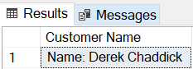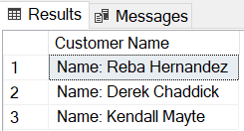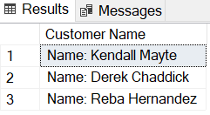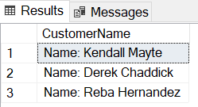

/\* 10. Select everything from the Customer Table and just the state names from the states table \*/

/\* NOTE: This is the book author's database, but you should always name your Primary Key in One table and the Foreign Key in the other table the exact same to avoid confusion \*/

select c.\*, s.StateName from customers c

left join States s on c.State = s.StateCode

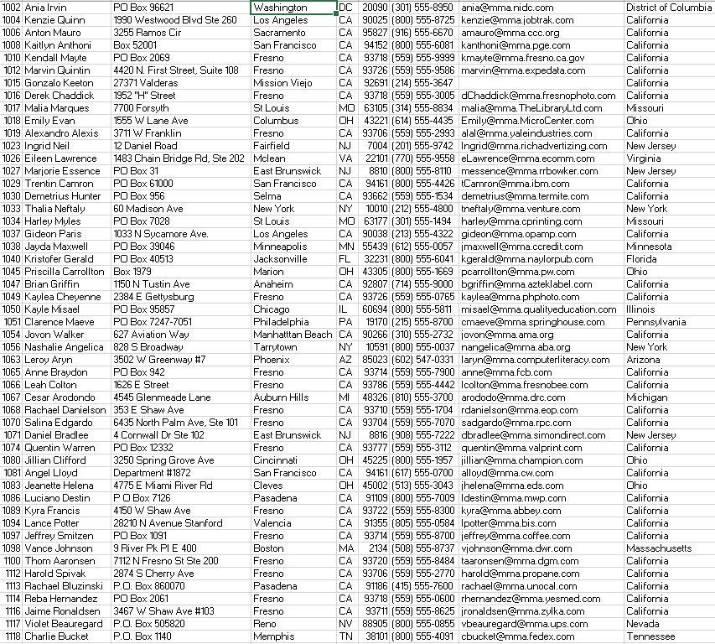

/\* 11. Get specific fields from both Customers and States \*/

select c.CustomerID, c.name, c.address, c.city, s.StateName, c.ZipCode from customers c

left join States s on c.State = s.StateCode

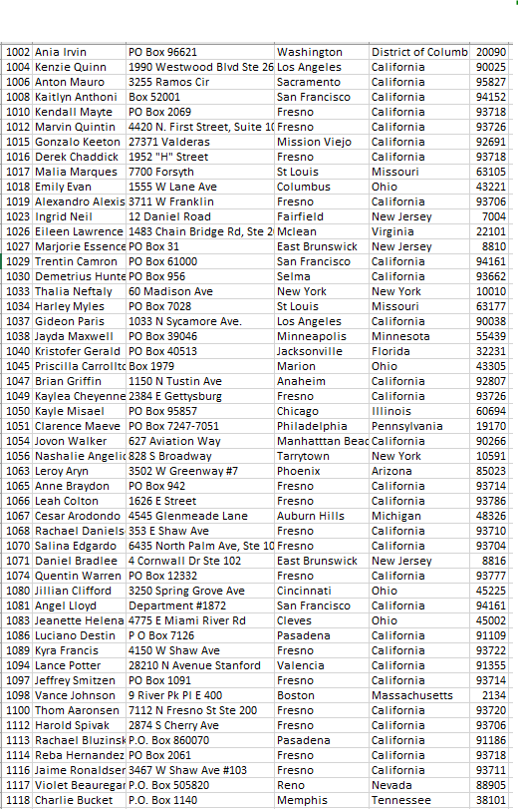

/\* 12. Count the number of incidents in the Incidents table for customer 1070 \*/

select count(\*) from Incidents where CustomerID=1070

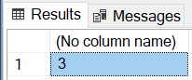

/\* 13. You can drag and drop fields from the Object Explorer window on to the Query Window. dbo stands for database owner... \*/

/\* try it now, drag and drop the products table then add SELECT Name from Products and Execute \*/

select \* from [dbo].[Products]

select Name from Products

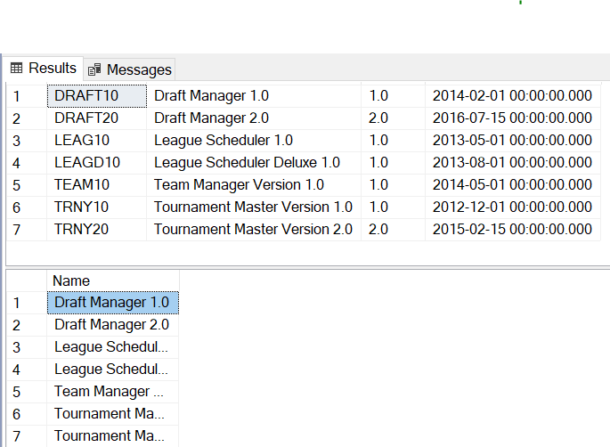

/\* 14. Get a specific date \*/

select \* from Registrations where RegistrationDate = '2013-09-19'

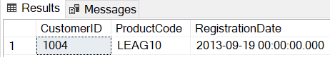

/\* 15. Get a specific date range, but not equal to those dates. \*/

select \* from Registrations where RegistrationDate > '2014-09-19' and RegistrationDate < '2015-01-13'

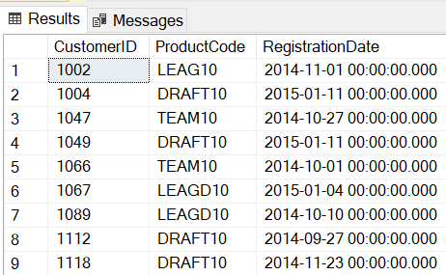

/\* 16. Get the TOP x records \*/

select top 2 TechID from Technicians

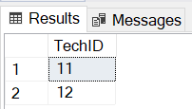

/\* 17. select distinct. Get unique instances from your table. You may have many customers, but you only want a customer listed once in this example. \*/

select distinct CustomerID from Incidents order by CustomerID

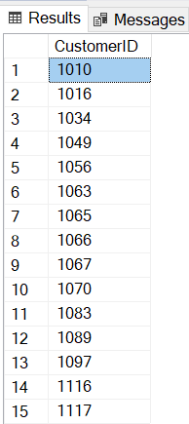

/\* 18. Get records where date/time field is not null. Here we are looking for Incidents which have been closed. \*/

select \* from incidents where DateClosed is not null



/\* 19. Get records where date/time field is null. Here we are looking for Incidents which have NOT been closed. \*/

select \* from incidents where DateClosed is null

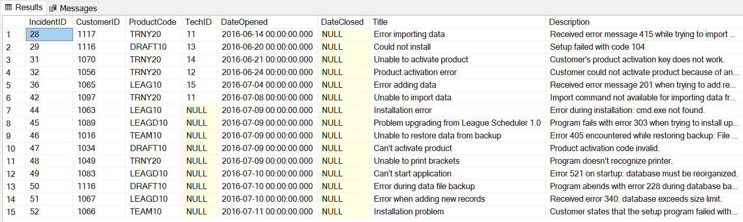

/\* 20. We are looking for specific zip codes only, use the IN reserved word. \*/

select \* from Customers where ZipCode in (20090, 93726)

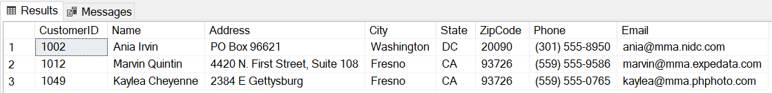

/\* 21. Want to get any incidents that aren't closed along with the TechID to see who is working on what to resolve issues \*/

select \* from [dbo].[Incidents]

select TechID from Incidents where DateClosed is null

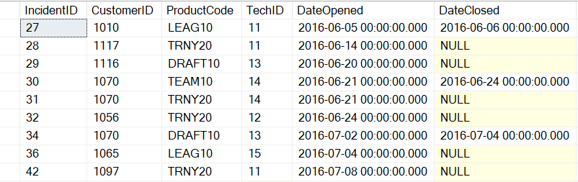

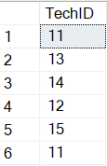

/\* 22. Want to see ProductCode that appears most frequently in the Incidents table \*/

select ProductCode, count (\*) as pro from Incidents

group by ProductCode

having count (\*) =(select max(pro) from

(select ProductCode, count(\*) as pro from Incidents group by ProductCode) Incidents)

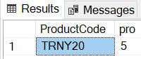

/\* 23. Want to see any incidents where activiation seemed to be the issue \*/

select \* from Incidents

where Description like '%activate%'

or Description like '%activation%'

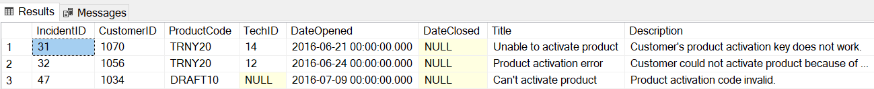

/\* 24. Want to see the CustomerID, ProductCode, and Description from Incidents to see which Product may have more issues with setup and installation. \*/

select CustomerID, ProductCode, Description

from Incidents

where Description like '%install%'

or Description like '%setup%'

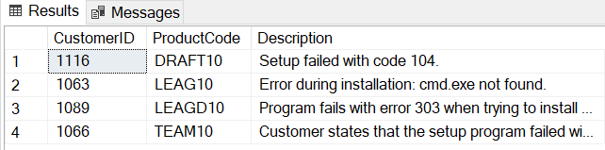

/\* 25. Want to see the ProductCode and ReleaseDate along with IncidentID and DateOpened to see if there is correlation between newer versions of products

and date opened of incidents that arose\*/

select Products.ProductCode, Incidents.ProductCode, Products.ReleaseDate, Incidents.DateOpened

from Products

inner join Incidents on Products.ProductCode=Incidents.ProductCode

